**Jenny’s Jewelers**





**Project Members**

* Abdul Samad
* Ali Abbas
* Syed Abdul Subhan
* Muhammad Yaseen
* Ahmed Jam

**TABLE OF CONTENT**

**Chapter Page No.**

Contents

Chapters 3

Certificate 4

Introduction 5

Problem statement 6

Project scope 7

Business Model Diagram 8

Work Break down Structure 9

Coding 10

Testing 12

|  |  |  |
| --- | --- | --- |
| S.R | Chapters | PAGE |
|  | Introduction  1.1 Purpose of the website | 5 |
|  | Problem Statement | 6 |
|  | Project scope  3.1 Design  3.1.2 **Visitor features**  3.1.2 Visitor features  3.1.3 Registered members panel | 7 |
|  | Business Model Diagram | 8 |
|  | Work break down structure | 9 |
|  | Coding | 10 |
|  | Testing | 11 |
|  |  |  |

|  |
| --- |
| Certificate We hereby understand the project criteria and this project is build, and this project is  made with the given circumstance / solution using the required technology.  We students of Aptech DHA Karachi Batch Code 20-20-11-G and we student name and id  ABDUL SAMAD Student1296623, ALI ABBAS Student1296621, SYED MUHAMMAD SUBHAN ALI Student1292471, MUHAMMAD YASEEN Student1290412, AHMED JAMEEL Student1292565 made the project under the supervision of our instructor / teacher Muhammad Amin  Student Name & Sign ______________  Date ____________  Student Name & Sign ______________  Date ____________  Student Name & Sign ______________  Date ____________  Student Name & Sign ______________  Date ____________  Instructor / teacher ____________ |

## Introduction

This website is made for the client jenny who runs store from her home with her best friend, but due to high numbers of demand of customers and the increase numbers of customers, our client jenny contact our team for her business solution and demanded an E-Commerce Website which will help her in business

1.1 **Purpose of this website and functionality:**

* Jenny can run her business from her home and due to increasing number of customer she doesn’t need to buy a shop
* Customer can also order products jenny without any difficulty from their shelter of their homes
* This website is user friendly with some latest functionality
* Reduce the need to redesign, recode, and retest.
* Website is based upon the need and suggestions of client

# Problem statement

* It is clear that nowadays technology is coming on their peak in this digitalization world, peoples also want things while sitting in their homes for example: if someone want food without going anywhere from the shelter of their homes so they simply order food from wherever they want to order and that’s the easy way to any service online because if businesses provide services to their customer because every business considered customer priority.
* Now a days E-Commerce Store are the best, easiest, simple and reliable way to sell different types of products or services to the peoples in this digitalization prefer to do things easily and smartly. When peoples lend on the E-Commerce site they expect to find things what they are looking for quickly and easily, mostly peoples are not sure about the prices, brand and the products they want to purchase. But the E-Commerce store plays important role in this situation so they can have considered products and brand through price and ratings comparisons. And some peoples have their business homes, so they operate their business through their E-Commerce Websites
* So there is a woman client name Jenny contact our team member basically Jenny is doing a business of cosmetics and imitation jewelry. She operates from home. Initially she started the entire activity by contacting the nearby friends and relatives, inform them about the various products available with her and their prices. Maria used to maintain the catalogue of products to display and diary for contacting the clients wherein she used to record their contact details and also to record their orders.
* With the growing demands of the business and the number of customer increasing day by day, she wishes to have a web site with the complete product list for the users also user should place the order of their products using website

## Project scope

The Project Scope is to provide easy and simple user interface which can be understand by the all users

3.1 Design

The application consists of following features

**3.1.1** Visitor features

* Home page
* Products mentions with process
* Log in and signup form
* Categories
* Add to cart

3.1.2 Registered members panel

* Login to site
* My profile
* My orders
* Buy products (Checkout)
* Logout

3.1.3 Admin Panel

* Login
* Dashboard
* Site members (Customers) management
* Administrator User management
* Products Price management

# Business Model Diagram

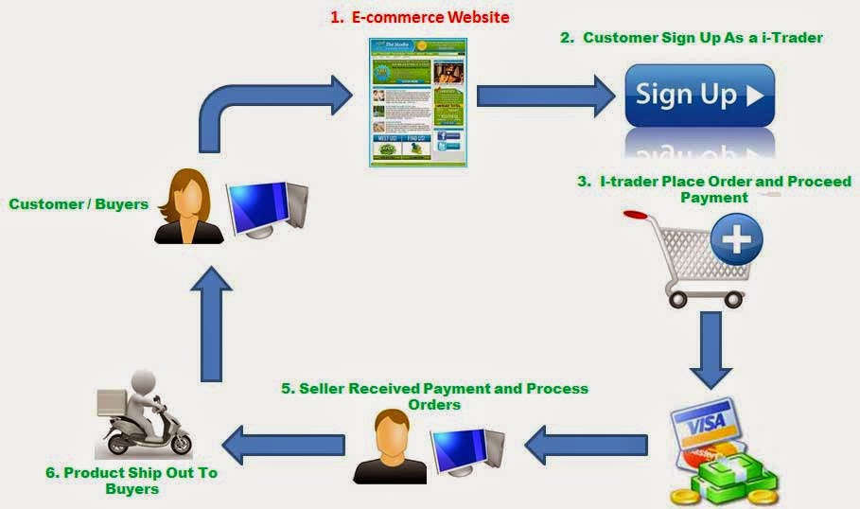

# Work Break down Structure

* Edit Record
* Delete Record
* Documentation

**Abdul Samad**

* Presentation

**Ahmed Jameel**

**Ali Abbas**

* User Authentication
* Insert Record

**Yaseen Tariq**

* View Record

**Syed Abdul Subhan Ali**

* Front-End
* Database Creation

# Coding

<?php

require 'config/dbc.php';

if(isset($_POST['submit']))

{

  $inputDate = DATE("y-m-d h:i:s A");

  $inputTitle = $_POST["inputTitle"];

  $inputCategory = $_POST["inputCategory"];

  $inputPrice = $_POST["inputPrice"];

  $inputDiscount = $_POST["inputDiscount"];

  // $userFile = $_POST["userFile"];

  $inputSlug = $_POST["inputSlug"];

  $status = $_POST["status"];

  $inputMetaDescriptions = $_POST["inputMetaDescriptions"];

  $inputMetaKeywords = $_POST["inputMetaKeywords"];

  //declaring variables

$filename = $_FILES['userFile']['name'];

$filetmpname = $_FILES['userFile']['tmp_name'];

//folder where images will be uploaded

$folder = '_assets/img/';

//function for saving the uploaded images in a specific folder

move_uploaded_file($filetmpname, $folder.$filename);

$sql = "INSERT INTO add_brand(`create_date`, `name`, `price`, `discount`, `category`, `slug`, `status`, `description`, `keywords`, `file`)

VALUES ('$inputDate', '$inputTitle', '$inputPrice', '$inputDiscount', '$inputCategory', '$inputSlug', '$status', '$inputMetaDescriptions', '$inputMetaKeywords', '$filename')";

if ($conn->query($sql) === TRUE) {

  echo "New record created successfully";

} else {

  echo "Error: " . $sql . "<br>" . $conn->error;

}

header("Location:view_brand.php");

}

?>

# Testing

